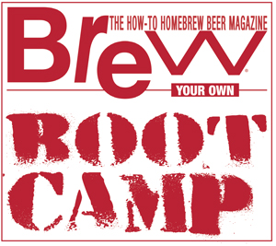

**EVALUATING BEER LIKE A JUDGE**

**ONLINE BOOT CAMP**

**FEBRUARY 28, 2025**

**BEER SHOPPING LIST**

As part of the upcoming Boot Camp, Gordon Strong will be holding live and interactive beer evaluations using several widely available commercial beers that you as an attendee can follow along in real-time evaluating the same beer yourself. Here’s your beer shopping list to have on hand for the February 28, 2025 event:

**1. Weihenstephaner Pilsner (Pils)**

(Substitute can be another German Pils)

**2. Guinness Draught (Irish Stout)**

Can or bottle version. (Substitutes can be Murphy’s, Beamish or O’Hara’s)

**3. Chimay Red (Belgian Dubbel)**

(Substitute is Westmalle Dubbel.)

**4. Old Speckled Hen (English Pale Ale)**

(Substitute is another English Pale Ale.)